50 things to do before you are 11 ¾ at Codicote School
Splash in puddles   | Watch tadpoles change to frogs | Play in the woods | Dance like no one is watching | Make a den  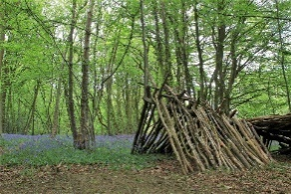 | Go on a residential journey | Read a book under the trees | Earn a gold Headteacher award   | Have a winter adventure with snow or ice | Stroke an animal  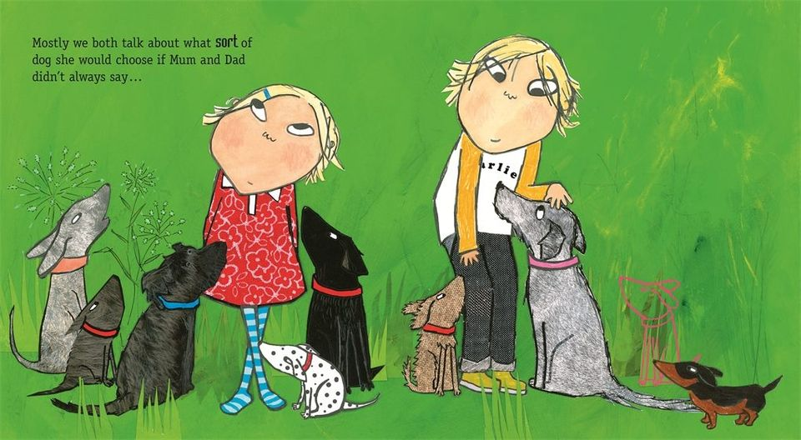
Play an instrument | Go on an adventure trip | Visit an animal park  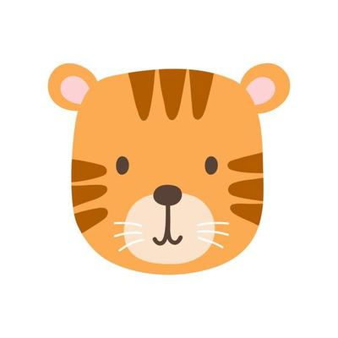 | Eat something you have grown | Walk through piles of leaves | Go cloud watching   | Be in a school play | Blow bubbles   | Get a badge or medal | Read a series of books
Hatch eggs   | Take part in a WOW! Day | Make a new friend | Go pond dipping | Do a mad science experiment | Look after the school office | Go to a museum  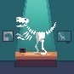 | Eat something you have cooked | Sing round a Campfire  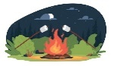 | Take part in the talent show
Belong to a school club | Build a sandcastle   | Go to the pantomime | Do a role which helps others | Fly a kite  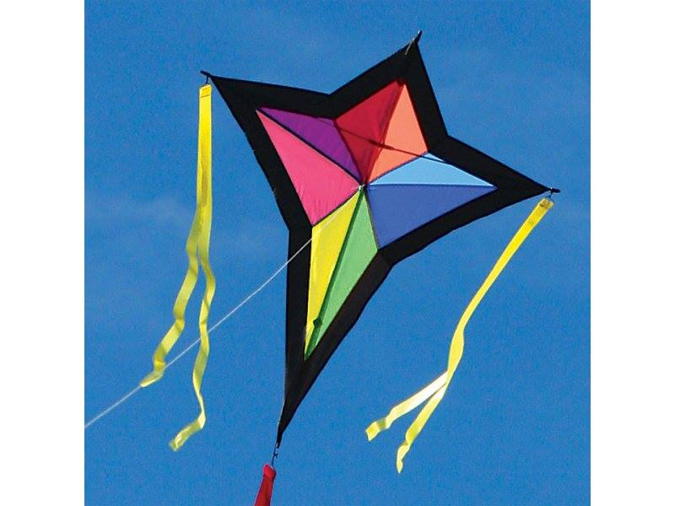 | Represent the school | Have a crazy hair day in school | Try to catch your shadow | Paddle in the sea | 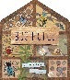  Study a mini-beast
Roll down a hill | Send a postcard   | Create a picture which goes on a wall | Make a mud pie  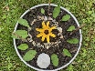 | Grow your own plant from a seed | Look after someone younger going to church | Take part in a Special Celebration Day | Ride a bike  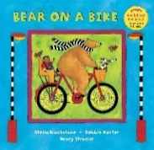 | Complete a jigsaw puzzle | Share a kindness with the community  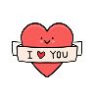
Name:

